

Association of Missouri
Interpreter’s Scholarships

George Kastler Graduate Scholarship
Aubree Schmid Undergraduate Scholarship

George Kastler Aubree Schmid

WHO:
The scholarships are open to students in Missouri colleges and universities or permanent Missouri residents
attending colleges or universities in another state or country. Applicants must be studying in the field of
interpretation (biology, environmental education, parks and recreation, wildlife management, history, etc.). Scholarships will be awarded to undergraduates currently in their junior or senior year and students currently attending graduate school.

WHAT:
The Association of Missouri Interpreters (AMI) wants to assist and inspire students by offering $1,000
scholarships and attendance to the AMI Conference. AMI will pay for the conference registration fee (which includes a one year AMI membership), one conference field trip, and lodging (site determined by committee). Conference attendance is not required, but strongly recommended.

WHY:
This scholarship provides educational funding, allows you to network and learn at the conference, and improves your resume.

WHERE and WHEN:

Springfield, MO, September 7th – 10th, 2025

HOW:

The attached application and required documents must be emailed or postmarked by July 15th.

Do you have QUESTIONS for the Scholarship Committee? Contact any of the members below:

Lee Wilbeck, Chair lee.wilbeck@dnr.mo.gov
Jada Tressler, Northwest jada.tressler@mdc.mo.gov
Rebecca Rodriguez, Northeast Rebecca.Rodriguez@mdc.mo.gov
Michelle Soenksen, Southeast michelle.soenksen@dnr.mo.gov
Cyndi Cogbill, Southwest cyndi@pawpawpatchproductions.com

John Cunning, Central cunningjd@hotmail.com
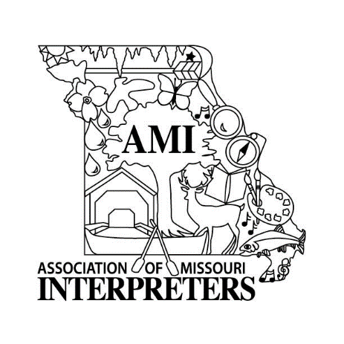

Association of Missouri
Interpreter’s Scholarships

George Kastler Graduate Scholarship
Aubree Schmid Undergraduate Scholarship

Scholarship includes $1,000, conference registration, one field trip, and lodging during the AMI Conference.

Date _____________________________________ (must be emailed or postmarked by July 15th)
Applicant Name ___________________________________________________________________________
Local Address _____________________________________________________________________________
E-Mail Address: ___________________________________________________________________________
Phone (________) _____________________________ Best Time to Contact: ________________________
Permanent Address________________________________________________________________________
Phone (________) ___________________________ Best Time to Contact: __________________________
Name of School Currently Attending _________________________________________________________
Check the appropriate level: Junior ______ Senior _______ Graduate Student _______
Major Area of Study____________________________ Minor Area of Study_________________________
Cumulative Grade Point Average______ Name of Academic Advisor_____________________________
Email and phone of advisor_______________________________________ (_______) ________________

Applicant Requirements:
- must attend a Missouri college or university or be a permanent Missouri resident, and
- must be an undergraduate junior or senior, or graduate student.

Your application will be scored on the following documents and their appearance. Please submit the following:
- this application,
- current college/university transcript (unofficial is acceptable),
- resume with references,
- an essay (at least 500 and no more than 1000 words) on why you are interested in the field of interpretation, and
- up to three (3) letters of recommendation relating information on your interpretation classes and/or experience.

For an application to be considered, it must be emailed or postmarked by July 15th.

Please submit your application, letters of recommendation, and accompanying documents to:

Lee Wilbeck - AMI Awards and Scholarship Committee Chair
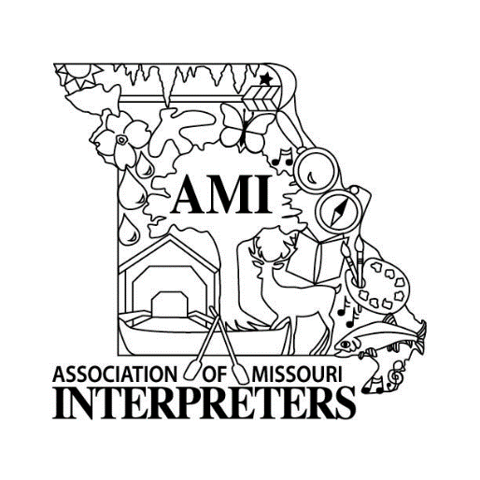
PO Box 314
Brookfield, MO 64628

lee.wilbeck@dnr.mo.gov

660-258-4950

