Association of Missouri Interpreter’s

Lou Clairmont Interpretation Grant

WHO:

Members of the Association of Missouri Interpreters (AMI)

WHAT:
This is an opportunity for AMI members to apply for funding that would aid in the creation of interpretive programs. The winners will receive funding to offset the cost of goods or services needed for their new or existing programs.

WHY:
This generous donation in honor of Lou Clairmont will assist AMI members in providing interpretive programs highlighting Missouri’s natural and cultural resources.

WHEN:

The application must be received via email or postmarked by July 15th.

HOW:
- Submit an Interpretive Outline complete with Theme and Title of Program
- Provide two additional examples of themes you could use while utilizing the purchased goods or services (in addition to the above outline)
- Include material list with specific costs just like you would for a grant
- Explain the need for financial assistance
- Recipient will be required to submit an article to the AMIgo describing the Interpretive Program created from the received grant within one year of receiving the funding

Submit application to:

Northern Regional Office

Lee Wilbeck, AMI Awards and Scholarship Chair
PO Box 314
Brookfield, MO 64628
Email: lee.wilbeck@dnr.mo.gov

Do you have QUESTIONS for the committee? Contact any of the members below:

Lee Wilbeck, Chair lee.wilbeck@dnr.mo.gov
Jada Tressler, Northwest jada.tressler@mdc.mo.gov
Rebecca Rodriguez, Northeast Rebecca.Rodriguez@mdc.mo.gov
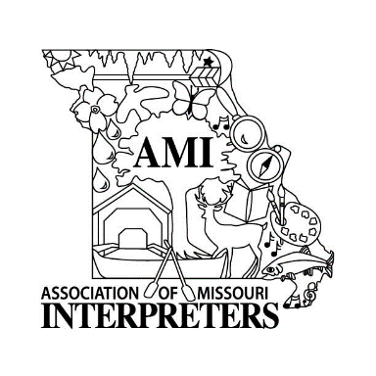
Michelle Soenksen, Southeast michelle.soenksen@dnr.mo.gov
Cyndi Cogbill, Southwest cyndi@pawpawpatchproductions.com

John Cunning, Central cunningjd@hotmail.com

Association of Missouri Interpreter’s

Lou Clairmont Interpretation Grant

AMI members may apply for one Lou Clairmont Interpretation Grant, per year. Grant funding each year will be capped at $500. Multiple grants can be awarded each year. Applicants must adhere to the requirements listed above. Grant funds will be given to the individual applicant, therefore items cannot be purchased using state office tax exempt qualifications. A detailed purchase list of items is required. Each item will need to be accounted for at exact cost. In addition to purchase price of all items, please include taxes and shipping cost as well.
All applications will be scored using the criteria below by the AMI Awards and Scholarship Committee, and will remain confidential. Applicants must receive a score of 80% or greater to receive grant funding.

Date ________________________

Name __________________________________________________________________

Address_________________________________________________________________

________________________________________________________________________

Email___________________________________________________________________

Phone_______________________________ Cell ________________________________

Place of Employment ____________________________________________________

Scoring Criteria:
- Program Outline including Theme and Title
- Additional Themes
- Detailed materials list including cost analysis
- Explanation of financial need

If any of the four criteria are not met, the application will not be scored.

Submit completed application by July 15th via e-mail (preferred) or postal mail to:

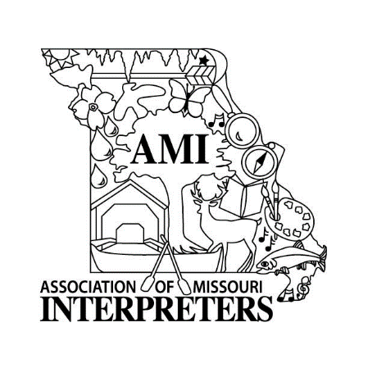
Northern Regional Office

Lee Wilbeck, AMI Awards and Scholarship Chair

PO Box 314, Brookfield, MO 64628

lee.wilbeck@dnr.mo.gov

